**Q4 Documentation**

Mahir Shadid – 01888504938 – [mahir.shadid@gmail.com](mailto:mahir.shadid@gmail.com)

**Q**. Now there is a happy path journey for searching with the text “Nike react phantom run flyknit 2”. Add a couple of small-sized black products to your cart. Then verify the Cart. Now execute the journeys from both API and UI. Now provide feedback on your test analysis, keep logs of the defects, and generate a report.

Analysis and Issues:

1. Without the documentation on the website, I had to research on the website and its elements (form POST action) for API testing. By following the steps below when I am on the website (https://demo.evershop.io/):

**Right click on mouse > Inspect > Network > Filter: XHR/Fetch**

1. In the table of the Network section, requests arrive when we work on a website. So I had to analyze the **requests** to get the necessary APIs from its **headers**, data structure from **payload** and **response**.
2. Verified the values of insertion from body while API testing in Postman on the response body graphql, HTML and JSON.
3. Added post-conditions based on expected results.
4. Defects or Bugs:

|  |  |  |  |
| --- | --- | --- | --- |
| **Name** | **Description** | | |
| **SKU vs Attributes (When selecting shoes)** | Although on UI, I select Black shoes, S size shoes as attributes but when testing API, I had to search for SKU in the Cart details, after searching for the product. Because it was flagged as required. | | |
| ***SKU input*** | | ***Attributes input input*** | |
| **Shipping/Billing Method in API** | The data input structure has an extra address object, while in the body of UI, I saw required was only ‘address_1’. Also the ‘address’ was requiring user information. | | |
|  | | | |
| **Shipping Method** | | | In the case of UI, I had to select “express delivery or standard delivery” but in API, I had to find out the “method-code” it was requiring from the HTML elements in the browser inspect session. And it wasn’t a readable code, like it is in “Payment Method”. |
| ***Shipping method*** | | | ***Payment method***  ***Payment method*** |

1. Collection from the Postman: <https://documenter.getpostman.com/view/23199592/2sAXqngkKq>
2. Test rail report also has been added as “testrail-report-2-q4”.
3. API Cart verification is:

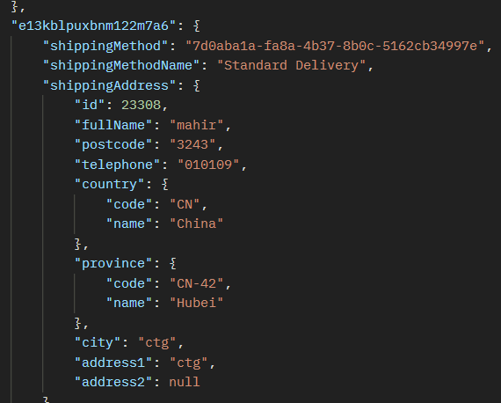

***User Info***

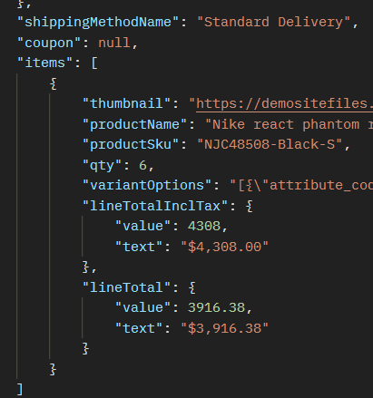

***Product Info***